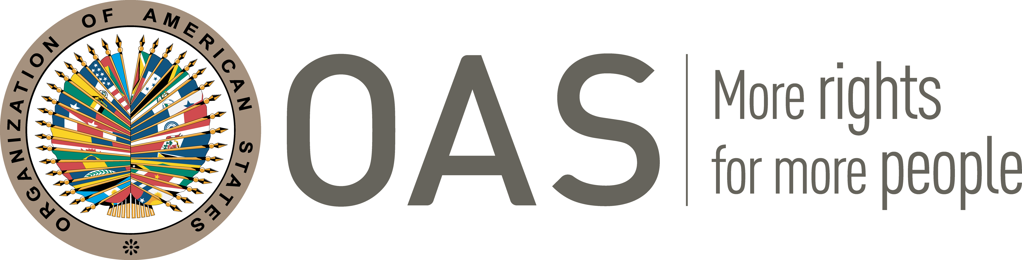

SECRETARIAT FOR STRENGTHENING DEMOCRACY
SUPPLIER INFORMATION

GENERAL INFORMATION
Fill out the form in CAPS

Personal Information (as it appears on your valid passport)
Last Name/s: MAGAR MEURS
Name/s: ERIC
Date of Birth (00-MONTH-0000): 12-JANUARY-1970
Address, City and Country of residence: NAYARIT 48, COL. ROMA SUR, DEL. CUAUHTEMOC, 06760 CDMX, MEXICO CITY, MEXICO
City and Country where you are flying from: NO FLIGHT SCHEDULED
Phone number with country and area code: +52 55 3143 8141
E-mail: EMAGAR@ITAM.MX
Nationality: MEXICAN (AND FRENCH)
Passport number: G14725410
Passport expiration date and city of emission: 6-JUNE-2024, CUAUHTEMOC MEXICO CITY

BANK INFORMATION
Fill out the form in CAPS

Bank’s Name: WELLS FARGO
Address, City and Country: UNIVERSITY TOWNE CENTER, 4315 LA JOLLA VILLAGE DR., LA JOLLA CA 92122 USA
Phone: (858) 250 2410
Name under account: ERIC MAGAR
Account No: 072-1558344
* ABA 121000248
** SWIFT: WFBIUS6S
IBAN (For Banks in Europe):

*ABA o routing number is a 9–digit number assigned to financial institutions
**SWIFT (The Society for Worldwide Interbank Financial Telecommunications) is required for International transfers WIRE

CORRESPONDENT BANK IN USA
In case your bank does not receive direct payment (check with your bank)

Name:
Address:
Phone:
Account Number of your bank in USA bank:
ABA:

